Power BI Assignment 3

Ans.1- Microsoft Power BI is a collection of tools used to import, aggregate and present data in the form of immersive and easy-to-digest reports and visuals. PowerBI is recognized as a leader among analytics and BI platforms by the major research companies (Gartner, Forrester, IDC, etc.). Best for data analysis for non-technical business users.

Products of Power BI :-

* **Power BI Desktop** – Power BI Desktop is a free application you install on your local computer that lets you connect to, transform, and visualize your data. With Power BI Desktop, you can connect to multiple different sources of data, and combine them (often called modeling) into a data model.

This data model lets you build visuals, and collections of visuals you can share as reports, with other people inside your organization. Most users who work on business intelligence projects use Power BI Desktop to create reports, and then use the Power BI service to share their reports with others.

* **Power BI Service** – The Microsoft Power BI service, sometimes referred to as Power BI online, is the software as a service (SaaS) part of Power BI. In the Power BI service, dashboards help you keep a finger on the pulse of your business. Dashboards display tiles, which you can select to open reports for exploring further.

Dashboards and reports connect to datasets that bring all of the relevant data together in one place. Power BI workflow, you begin by building a report in Power BI Desktop, then publishing it to the Power BI service.

* **Power BI Mobile** – The Power BI mobile app for the Android phone brings Power BI to your pocket, with up-to-date, touch-enabled mobile access to your business information. You can filter a report by your geographic location. You can scan QR codes with your Android phone and go straight to a Power BI dashboard or report.
* **Power BI Report builder –** Power BI Report Builder provides data visualizations that include charts, maps, sparklines, and data bars that can help produce new insights well beyond what can be achieved with standard tables and charts. It is a tool for authoring paginated reports that you can publish to the Power BI service. Paginated reports are designed to be printed or shared. They're formatted to fit well on a page, and they display all the data in a table, even if the table spans multiple pages.
* **Power BI Report Server –** Power BI Report Server is an on-premises report server with a web portal in which you display and manage reports and KPIs. Along with it come the tools to create Power BI reports, paginated reports, mobile reports, and KPIs. Your users can access those reports in different ways: viewing them in a web browser or mobile device, or as an email in their in-box.

It is similar to both SQL Server Reporting Services and the Power BI online service, but in different ways. Like the Power BI service, Power BI Report Server hosts Power BI reports (.pbix), Excel files, and paginated reports (.rdl) . Like Reporting Services, Power BI Report Server is on premises. Power BI Report Server features are a superset of Reporting Services: everything you can do in Reporting Services, you can do with Power BI Report Server, along with support for Power BI reports.

* **Power BI Embedded** – Power BI embedded analytics allows you to embed your Power BI items such as reports, dashboards and tiles, in a web application or in a website. You can:

Deliver compelling data experiences for your end users, enabling them to take action based on insights from your solutions data.

Quickly and easily provide exceptional customer-facing reports, dashboards, and analytics in your own apps by using and branding Power BI as your own.

Power BI embedded gives you additional benefits over secure embed. It offers a rich, fully integrated experience with full API support, automatic authentication, and the reports can be hosted in apps as well as web pages. Embedded analytics allows you to automate the monitoring, management, and deployment of analytics, while getting full control of Power BI features and intelligent analytics.

Ans.2- Excel has limitations in the amount of data it can work with. In contrast, Power BI can handle much larger amounts of data. Power BI can connect to a large number of data sources, while Excel's connectivity capacity is limited. Also, unlike Excel, Power BI can be easily used from mobile devices.

* Excel is used to organize data, transform it and perform mathematical operations and calculations. On the other hand, Power BI was conceived as a business intelligence and data visualization tool for businesses , moreover excel has limitations in the amount of data it can work with. In contrast, Power BI can handle much larger amounts of data.
* Power BI can connect to a large number of data sources, while Excel's connectivity capacity is limited. Also, unlike Excel, Power BI can be easily used from mobile devices.
* Power BI has faster processing than Excel and the dashboards are more visually appealing, interactive and customizable than those in Excel.
* Power BI is a more powerful tool than Excel in terms of comparison between tables, reports or data files and it is more user friendly and easy to use than Excel

Ans.3- Power Query is a data transformation and data preparation engine. Power Query comes with a graphical interface for getting data from sources and a Power Query Editor for applying transformations. Because the engine is available in many products and services, the destination where the data will be stored depends on where Power Query was used. Using Power Query, you can perform the extract, transform, and load (ETL) processing of data.

The Power Query user experience is provided through the Power Query Editor user interface. The goal of this interface is to help you apply the transformations you need simply by interacting with a user-friendly set of ribbons, menus, buttons, and other interactive components.

The Power Query Editor is the primary data preparation experience, where you can connect to a wide range of data sources and apply hundreds of different data transformations by previewing data and selecting transformations from the UI. These data transformation capabilities are common across all data sources, whatever the underlying data source limitations.

Power Query can be used in many products, such as Power BI and Excel. However, using Power Query within a product limits its usage to only that specific product. Dataflows are a product-agnostic service version of the Power Query experience that runs in the cloud. Using dataflows, you can get data and transform data in the same way, but instead of sending the output to Power BI or Excel, you can store the output in other storage options such as ‘Data verse’ or Azure Data Lake Storage. This way, you can use the output of dataflows in other products and services.

With Power Query (known as Get & Transform in Excel), you can import or connect to external data, and then shape that data, for example remove a column, change a data type, or merge tables, in ways that meet your needs.

Ans.4- Microsoft Power Map for Excel is a three-dimensional (3-D) data visualization tool that lets you look at information in new ways. A power map lets you discover insights you might not see in traditional two-dimensional (2-D) tables and charts , With Power Map, you can plot geographic and temporal data on a 3-D globe or custom map, show it over time, and create visual tours you can share with other people.

You’ll find the *Map* button in the *Tours* group on the *Insert tab* of the Excel ribbon.

We can use Microsoft Powermap for Excel to:

* Map out data – We can visually plot over a million sets of data in 3D format inside our Excel worksheet.
* Discover fresh insight - We can acquire new understanding by observing our data in a geographic setting and seeing timestamped data changes over time.
* Share stories - By capturing screenshots and building guided cinematic video tours we are able to share broadly, and engage audiences on a wider scale.

How to create an Excel Powermap (note : I took this from google)

When we have Excel data which consists of geographic properties on our worksheet for example, columns and rows that contain zip codes, names of cities, longitudes and latitudes, states, countries/regions, we can get started by following the simple steps below:

1. The Map button is located under the “Tours” group on the “Insert” tab of our Excel  worksheet ribbon, as shown below;

*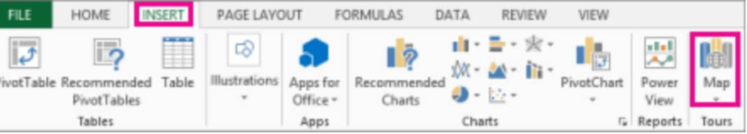Figure 2. Map Button in Excel*

1. Select any cell containing demographic data in our worktable, and then click on “Insert” > “Map”. Clicking on the “Map” button will automatically enable Power Map for Excel.

*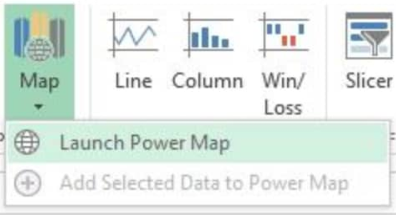Figure 3. Launch Power Map in Excel*

Excel Powermap then uses Bing to find geocodes for our data based on their geographic properties. After a few seconds, a globe will appear beside the first screen on the “Layer Pane”;

1. On the “Layer Pane”, ensure that fields are correctly mapped out and then click on the drop-down arrow to any incorrect fields and match them to their appropriate geographic properties;

*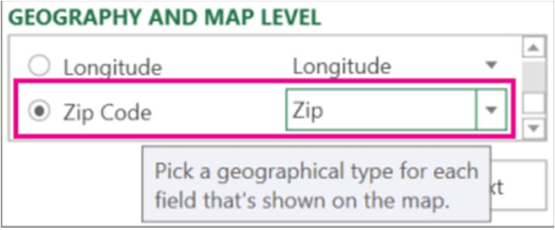Figure 4. Layer Pane for Powermaps in Excel*

In the example above, we must ensure that our Zip Code has been recognized as “Zip” in the drop-down menu box.

1. When Excel Powermap plots our data, several dots will appear all over the globe;

 *Figure 5. Power Maps in Excel*

Click on “Next” to begin visualizing and aggregating our data further on the map.

Ans.5 – SharePoint On-Premise is commonly maintained by a company’s IT team at its data center. The team must keep it up to date via patches and other relevant updates. The on-premise SharePoint runs on a Client Access License model (Server/CAL), which gives users the legal right to access services within a server.

Power BI Report Server is an on-premises report server with a web portal in which you display and manage reports and KPIs. Along with it come the tools to create Power BI reports, paginated reports, mobile reports, and KPIs. SharePoint Online comprises both web and cloud-based technologies. It eliminates high data storage costs, subscription charges, and other SharePoint on-premises deployments.

The primary benefits of migrating to the SharePoint Online platform are:

* The ability to integrate with Microsoft 365 applications
* High-level security features
* Compatibility with mobile devices, so information is accessible on the go
* Easy external collaboration efforts with users
* HIPPA, FIMSA, and ISO27001 compliance, among others
* Ability to create document libraries for enhanced collaboration efforts

Ans.6 – As you might already know Microsoft announced Power BI 2.0 General Availability, Power BI 2.0 GA, on July 24. In this post I explain some new features that are ready to use now. Now I can say Power BI is significantly improved during the preview period. We are able to refresh on-prem datasets, we can modify the look and feel of the reports, we can share resources and much more now. For instance, go to Power BI website and the first thing you can see is the Power BI logo is changed from Power BI Preview to Power BI.

Now we can get data as :

* Sign into Power BI
* Click on Get Data button from the bottom of the left navigation pane
* There are now two different sections in the “Get Data” of your workspace which each of them have two parts : *Content pack library* and *Import or connect to data.*
* The report’s features are improved significantly. We can know change the chart’s colors, adding free texts into Textboxes and much more.
* After logging into Power BI website clock on a desired report and right after you open the report you’ll get prompted to use the new report canvas
* After you open the report, click on EDIT REPORT
* With the new features we are able to modify the visualization as desired
* By clicking a chart related features to the chart is added to the visualization pane, In this sample I clicked on a bar chart
* You can also simply enable Data labels by clicking on “Data Labels”. You can customize the data labels by changing color or precision
* You can also change the chart’s title text and customize it as desired by expanding “Title”
* As you noticed you can always back to default by clicking on “Revert to Default”
* You can save the report or save it as a new report

This is a really awesome feature that I can update the content pack so that the users can always have the latest versions. To update the content pack just simply click on “Edit” then click “Update”.

This is another cool feature which is newly added. Now you can easily switch to your Power BI for Office 365 account. There is also a link for Power BI which is newly added to Power BI 365.